Planned burns in your area
  - Ovens Fire District
Forest Fire Management Victoria (FFMVic) will be conducting planned burning in this area in Autumn and Winter when conditions are suitable.
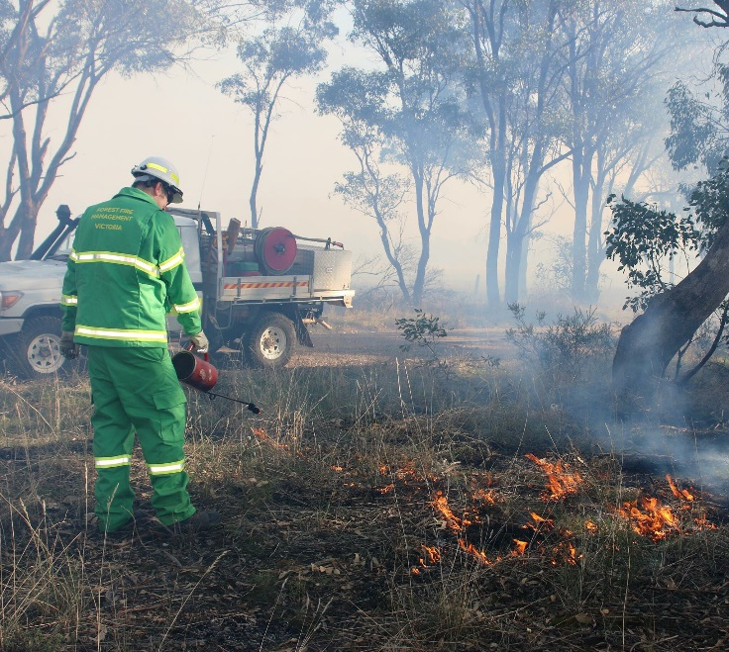
Crews from FFMVic work alongside the Country Fire Authority (CFA) to carry out a fuel management program, in Victoria’s public parks and forests and on private land, to reduce the risk of bushfire to people, property and the environment.
Fuel management is one of the most effective ways to reduce the impact of bushfire - it includes works such as planned burning, slashing and constructing fire breaks. These works help to reduce fuel (flammable vegetation) which reduces the risk of a bushfire.
If a bushfire does occur in an area where fuel management has occurred these works can help reduce the bushfire’s intensity and impact.

When will these planned burns happen?
Each burn is part of the Joint Fuel Management Program outlining where FFMVic and CFA intend to carry out fuel management works ffm.vic.gov.au/jfmp
Although burns are scheduled to take place in a certain year and season, this can change depending on weather and local conditions.
FFMVic is unable to give you an exact date when this burn will go ahead - the final decision to proceed can only be made on the day of the burn, following monitoring of weather conditions and local fuel moisture levels.

Planned burns - what can you expect to see?
Before the burn takes place, crews will prepare the site. This can include trimming or removing hazardous trees and clearing control lines around the burn edge.
On the day of the planned burn you may see smoke and flames. Some roads and tracks may close or have speed restrictions. Fire fighting vehicles and crews will be in the area.

How can I find out about a burn near me?
Stay informed about when burns may occur.
Visit ffm.vic.gov.au/plannedburn
Call VicEmergency Hotline 1800 226 226
Download VicEmergency App
Register Planned Burns Victoria
plannedburns.ffm.vic.gov.au

We encourage you to sign up for the Planned Burns Victoria – you can set up automated SMS and email notifications about any upcoming FFMVic and CFA planned burns on public and private land. There is no charge to register or to receive messages.
For further information about planned burning, please contact your local FFMVic office on (03) 57311222 or ovens.plannedburning@delwp.vic.gov.au.
Thank you for your patience and understanding while we do this important work to better protect communities, property and the environment from the impacts of bushfire.

Protect your health from smoke
Plan ahead for yourself, your family members and home during and days following the planned burn.
- Smoke can affect people’s health.
- People with heart or lung conditions (including asthma), children, pregnant women and older people are more sensitive to the effects of breathing in smoke.
- If smoke is from a planned burn stay indoors (if possible) with windows and doors closed. If using an air conditioner, switch it to recycle / recirculate to reduce smoke coming into your home.
- Avoid physical activity.
- If you have asthma or respiratory conditions, follow your prescribed asthma management plan and keep a reliever or inhaler on hand. If you have existing heart or lung conditions, follow the treatment plan advised by your doctor.
- If you develop symptoms such as shortness of breath, coughing, wheezing or chest pain, follow your prescribed treatment plan (if you have one), but if symptoms don't settle, seek medical advice or call Nurse-on-Call on 1300 606 024
- You may wish to leave the area while it is affected by smoke, if practical to do so.

Prepare your property for the planned burn
- Close external doors and windows
- Bring washing inside
- Secure your pets – animals may find a burn in the area distressing. Consider relocating pets for the day if they may be distressed or affected by smoke.

Keep this information for later reference
We recommend you keep this information handy and refer to it as burn day approaches.
- Share this information with other people in your home or business, especially with anyone who may be at your address during the burn.
- Seek updates using the sources provided above.
- Sign up to the Planned Burns Victoria system. Receiving a message that the burn is scheduled to happen soon is a good trigger to check that you, your family and your pets are ready for the burn.
Thank you for your patience and understanding while we do this important work to better protect communities, property and the environment from the impacts of bushfire.

Ovens Fire District Planned Burning Program for Autumn 2020

Burn Name | General Location | Burn Size (ha)
Ben Valley – Ben Valley Track | 9km Southeast of Yackandandah | 1336
Chiltern – Red Box Track | 2km Northwest of Chiltern | 66
Germantown – German Creek Track | 4km East of Bright | 2186
Mt Pilot – Old Coach Road | 6km East of Mount Pilot | 250
Myrtleford – Nine Mile | 11km Southeast of Myrtleford | 978
Nug Nug – Masterton Hill | 11km South of Myrtleford | 179
Running Creek – Kiewa Divide | 13km South of Dederang | 766
Shannonvale – Fitzgerald’s Road | 25km Northwest of Omeo | 1010
Stanley – Cue Springs | 5km South of Stanley | 76
Tawonga – German Creek | 7km Northwest of Mount Beauty | 818

